|  |  |  |  |  |  |
| --- | --- | --- | --- | --- | --- |
| Date | 8-Sep-22 | | | Tester Name | Mohammad Yusuf |
| Environment | Penfax - Test | | | Login used |  |
| Operating System | Select OS | Version: | Update: | | |
| Software Used | Select Software | Version: | Update: | | |
| Select Software | Version: | Update: | | |
| Release version |  | | | | |
| Title | M17 Contributions & DCT | | | | |
| Test Type | Regression | | | | |
| Test Scenario | M17.16 Running Employer Contribution Detail | | | | |
|  |  | | | | |
| Expected Results | Contribution file details should be available in the report. | | | | |
| Pass/Fail | Pass | | | JIRA# | N/A |

Describe your steps with screenshots:

1. Log into MEPP DCT and select the Employer from the dropdown.

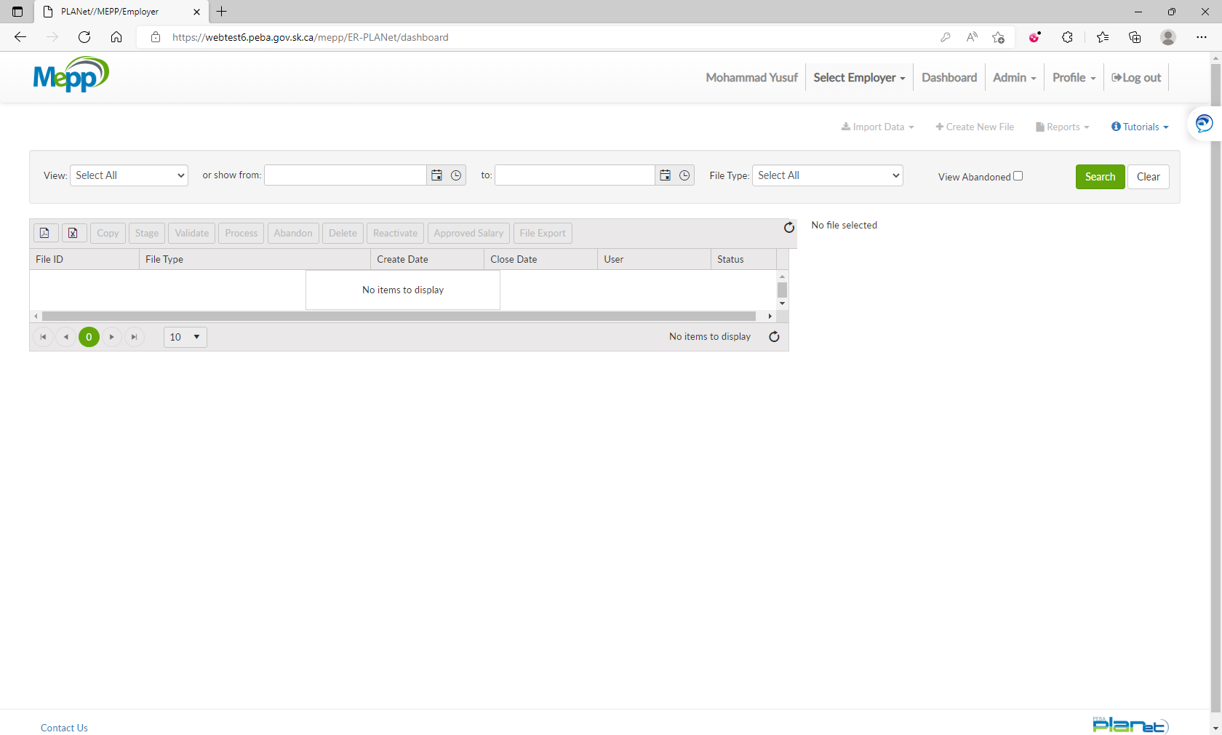

1. Select any of the processed contribution files.

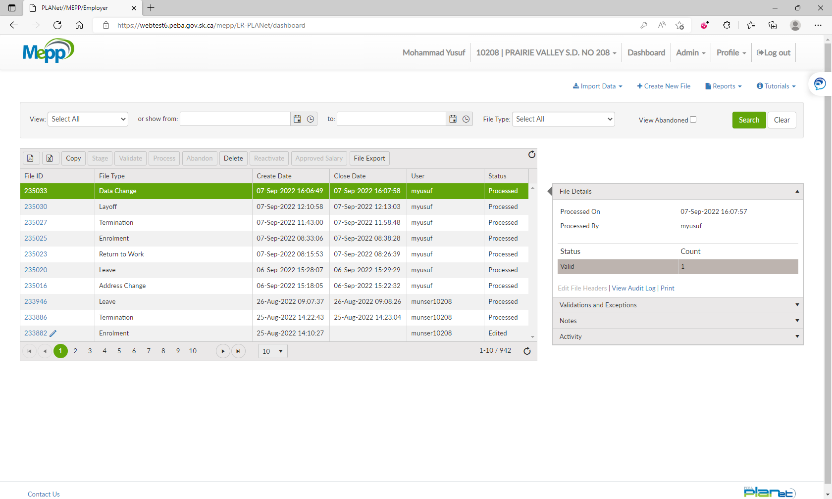

1. Click on Reports and select Employer Contribution Detail.

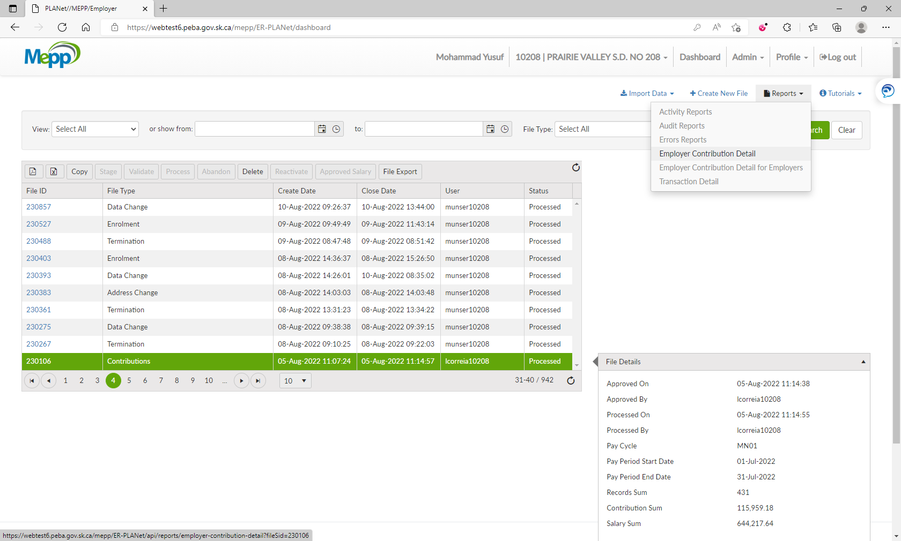

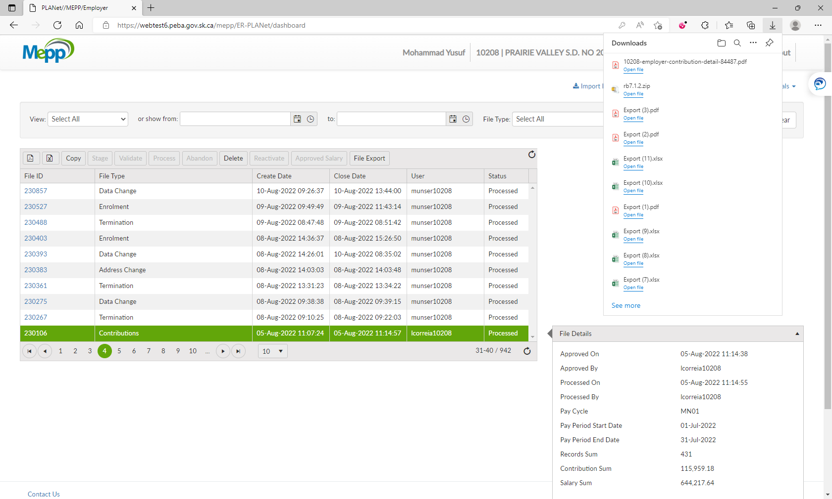

1. It will open a report in PDF format.

